Permanent contamination of the Earth by 5G network and voluntary acceptance of enemies’ application of electronic warfare

Dr. Diana Wojtkowiak
Gdańsk
www.torsionfield.eu

Translation by Piotr Bein, 1.7.2019
Piotr Bein's blog = blog Piotra Beina ( https://piotrbein.wordpress.com/ )
[…] = to be continued.




To the Sejm [Poland’s Parliament] on 26th of April, 2019

This text was to be a speech at the Sejm conference on April 26, 2019, “5G: Opportunities and Threats”, and thus was dedicated to a limited circle of deputies and persons particularly interested in this topic. However, due to rejection of my speech and a decision that only tenure professors may speak at the conference, this text reaches a wide audience, whom the legislature would perhaps not really want this information to reach. So, the discussion is out of necessity transferred to the whole country, instead of taking place at the proper place — the Sejm. The deputies will be able to find this information on the Internet, on an equal footing with the citizens.

Electromagnetic field and torsion field

It is well known by now that electromagnetic fields do not affect living organisms below the thermal effect, since they do not have appropriate antennas. The electromagnetic field is only a small part of the problem of microwave transmitters that send accelerated particles of the torsion field, while the particles of the torsion field of different origin are responsible for a large part of the civilizational diseases.
This aspect of the presence of particles of torsion fields, which can also be
used in a hybrid war, is the main issue in this speech.
It consists of three parts:
1. A brief introduction to the modern use of torsion field particles, without explaining of what they are. An introduction to the properties of torsion field particles can be read on www.torsionfield.eu.
2. The unique opportunities to use 5G networks for personalized particle transmission of torsion fields carrying biological information and being a cure or, on the contrary, possessing lethal properties.
3. Results of research on accumulation of torsion field particles in the ground. The research was carried out on a 4G network, particularly for this conference.
The majority of Polish and European public don’t really know anything about torsion fields, and more so about the particles of torsion field. This is in line with the concerns of the state powers’ military circles who say this knowledge is off limits for us. In Russia, where torsion field studies fell into civilian hands following the collapse of the Soviet Union, the Federal Security Service of the Russian Federation has again classified latest achievements in this area.
Despite the desire for modernity, 5G network does not arouse enthusiasm. Student-like ideas of a house, equipped with a hundred cameras and a hundred other sensors, are some sort of childishness. Should the house be a lunar lander equipped with the latest research apparatus? With a population of only 8 million, Israel sends landers to the Moon. Forty million Poles will spend momey in the several hundred billions to create a 5G farm to grow clumsy fatties. We need that kind of money for rockets, not for fast computer games and downloading of movies. Two weeks ago, India has launched a satellite capable of taking off enemy satellites, thereby joining the club of military space powers. Unsuitable people came to power in Poland, but also in declining world power Europe, since such abysmal programmes undergo implementation. A super-network that cannot function in rain — is it black English humor?

Applications

Critical mass reduction
I have been experimenting with torsion fields for many years, with particles of the torsion field in particular. They have properties that can stun an experienced physicist from the ancient twentieth century. Torsion fields are brilliant, for example,
in reducing the critical mass of nuclear bombs, including those that a month ago the Americans brought from Germany to Suwałki area in northeastern Poland, under helicopter escort in a spectacle of lights. For an expert in torsion fields, the bombs are perfectly visible from weather satellites. A portion of the particle spectrum for the torsion field shows that these are plutonium and uranium bombs (fig.1).

Fig. 1

For three years the Russians have been experimenting with a method for reduction of critical mass in Ukrainian nuclear reactors, where some of them operate at half the design power, lest next Chernobyl happens. Torsion field is beamed at the nuclear plants from several directions. The idea of melting nuclear fuel in enemy’s nuclear silo is a very promising and elegant warfare technique, hitting the military not the civilians, unlike the wars in the Middle East. NATO nuclear bombs 20 km from the Kaliningrad Oblast border, i.e. within direct observation range of a thermal camera, is a tasty treat for the Russians! Comrade Putin told the truth; he does not intend to drop nuclear bombs on the launchers in Poland. He will simply melt them, generating smoke for many years to come.

Cold fusion
[…]

Satellite detection of deep geological deposits
[…]

Torsion field particles sent over the Internet
[…]

Remote genetic manipulation
Radionic methods make possible more ambitious projects of transmitting whole genes by radiofrequency links, and transferring them to living organisms for gene therapy, or, on the contrary, for selective covert murder, depending on the implementer. Let’s not expect the military to busy themselves with gene therapy. Torsion field particles make possible copying, in the form of torsion field, DNA’s original chemical form. Transfer of the particles to human body causes cheating of natural mechanisms and re-construction of the transferred DNA in cells.
The first succesful reproduction of DNA from a torsion field signal sent over the Internet accomplished Nobel Prize winner, Luc Montagnier, a few years ago. Gene 16S of Borrelia burgdorferibacteria, causing Lyme disease, sent as torsion field, was re-produced in so-called PCR reaction. The analysis result using electrophoresis appears below (fig. 8).
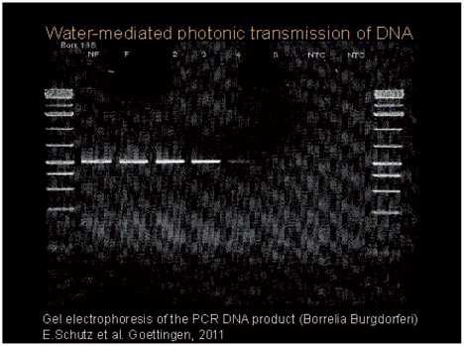

Fig. 8. PCR product re-produced from torsion field. (Luc Montagnier)

Sequencing agreed with the original. Similar effect was subseqauently obtained in human cell cultures. Later, Peter Petrovich Gariaev repeated radio frequency experiment of DNA reproduction, using plazmid DNA (fig 9).

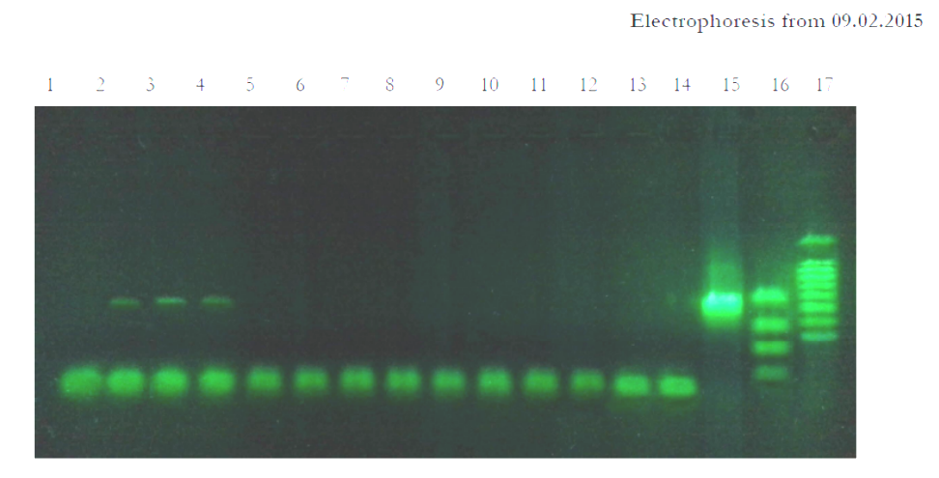

Fig. 9. Paths 2 to 4: 547bp product replicated from torsion field; path 15: standard DNA
(Peter Gariaev)

Gariaev also successfully carried out a gene therapy experiment, by transferring genetic information from torsion field of a healthy person to a patient with cystic fibrosis.
These are preliminary experiments that, improved and utilizing high-quality links e.g. 5G, will make replication of viruses possible in humans from information sent by radio waves or the Internet.. Such selected signals could be transmitted to a targeted person in the form of a picture radiating the information from a computer screen directly into the body with microwaves, but also by a sound signal — for music lovers.
It is an advanced method using 5G, known only to a small circle of scientists. Many solutions for 5G network arose, however, from a more mechanistic approach to warfare using high-performance telecommunication network. No big imagination is needed to connect the dots for what for is in 5G network the tracking of all people to 10 cm, requiring face recognition software and efficient microprocessors. Is suffcies to look up two recent books:
Ronen Bergman; Rise and Kill First: Secret History of Covert of Israel’s Targeted Assassinations; Yaakov Katz, Amir Bohbot; The Weapon Wizards: How Israel Became a High-Tech Military Superpower.
The first book shows a long history of selective assasinations by Mossad. The second one, beside aspects of Israel’s armaments, shows application of rockets to individual enemy killing, where currently the target strike precision is 10 cm. For selective killing, small rockets were developed to fly on only 800 g of trotyl, limiting the number of coincidental victims. A weak point of selective killing is deciding whom to kill and where a particular person is currently located. To this end, a fifth column is trained, consisting of intelligent people who learn Arabic, study Koran and Arab behaviour, risking their life pretending they are Arabs. The solution to his problem will arrive with 5G network that tracks everyone to 10 cm, and with Internet corporations that engage in spying.
How to accomplish a Blitzkrieg in 15 minutes using the technology progress of 5G? Launch 5000 rockets in a very short time, before an alarm sounds off. The rockets come in through windows, killing 5000 persons selected by Google company from among the enemy’s intelligentsia. A country bereft of current and future leadership will surrender to the occupier. 5000 is not many. Israel makes rockets capable of taking out missiles caliber 150 mm, in a quantity assuring destruction of of all 100 thousand rockets of Libian Hezbollah. Selectibe murder with individual rockets has been a standard method of the Israeli army and Mossad for many years and is acceptable to 90% of Israeli society. USA has taken the method from Israel to use in many countries, for example in Iraq and Afghanistan.
Ground phantom of torsion field and the cancer epidemic
According to most of the several thousand scientific publications on electromagnetic field (EMF) research that I got to know, human and animal cell metabolism disorders occur at microwave radiation levels below Polish guidelines, and at low-frequency EMF intensities are 17 orders of magnitude below the thermal effect. My own research in progress on the HSP70 gene affected by a coil powered by 20 – 80 Hz also confirm metabolic changes in human cells.
The environmental risk situation looks guite simple: USA – 50% of citizens die of cancer. Poland – 25% die of cancer. US limit for microwave radiation in USA is 10 W/m2, in Poland it is 0.1 W/m2. In the past, incidence of cancerwere rarer — morbidity around 2% of the polulation. It’s known since the 1990s that torsion fields, not the EMF, are responsible for harm from transmitters (Anatoly Akimov). Already then I was able to find such information on the Internet, in Russian.
Unlike lifeless nature, living organisms can receive torsion field signals. When a microwave device disturbs physiology over the effects of weather, diet and bio-cycles, then the technology is unacceptable and must be changed. It is sufficient in scientific research to show permanent changes in receptor function, protein kinase paths and DNA methylation. This type of data, not the number of dead rats, enables us to foretell a likely catastrophe years ahead.
The link between cancer incidence and electrification was noticed in the USA already before the Second World War, but the epidemiological data was classified (fig. 10).
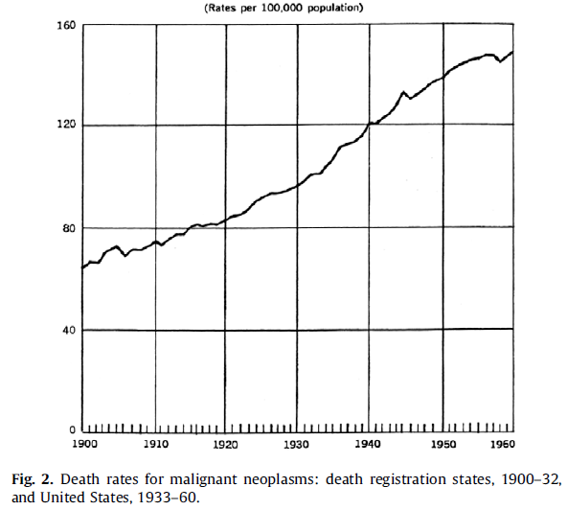

Fig. 10. The graph on the left shows increased cancer morbidity in the USA between 1900 and 1960. The graph to the right compares cancer morbidity for poorly electrified and fairly electrified Louisiana (48.9% in 1940) — violet columns, with better electrified Massachusetts (97.6% in 1940) — green columns.

Torsion field radiation from a 400 kV power line

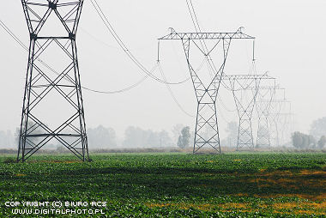

Fig. 11. 400kV powerline

The torsion field was tapped with a colour adder and a kinesiological-type impact. EMF drops with distance faster than the torsion field, and much faster than illness incidence caused by the power line (fig. 12)

Fig. 12. The graph compares EMF and torsion field levels with an excess number of leukemia cases in children living near very high-voltage power lines — 400 kV and 275 kV. The upper curve approximates the drop in number of cases with distance from power line, found in British studies. The authors took 600 m as a range of the effect, and relative incidence on the vertical scale, in per mille units, was calculated by dividing the number of leukemia cases inside the 600 m range by the number of cases outside it. The curve in the middle shows torsion field radiation assessed in the woods by colour adder in a 400 kV power line direction. Electric and magnetic field measurements in April 2019 were concurrent with torsion field assessment. The two bottom curves represent the electric field (V/m, small black dots) and the magnetic field (nT, large red dots).

In the next graph of radiation spectrum taken from the ground level, high-voltage power line signal dominates the one from the ground (fig 13).

Fig. 14.

Base tranceiver stations of the cell telecommunication systems

Fig. 15.

The first graph (fig15) compares spectra of torsion field signals from a cell system transceiver located at Przyjaźń near Gdańsk, and from the field’s accumulated phantom radiating from the ground below. Measurements were done 1000 m from the transceiver. Legend for the graph: e- = electron, Al = aluminum, O = oxygen, Fe = iron, NiFe = combined iron and nickel signal from Earth’s core, Cu = copper, Ga = gal, As =arsen, Sn = tin, Bi – bismuth, U – uranium, f – peaks due to transceiver transmission frequency, symmetric to the aluminum peak. Horizontal scale = angle in degrees, vertical scale = radiation range in cm, averaged out over Categories in spectrometer output samples.

Fig. 16

Next, the two graphs (fig. 16) show the decrease of torsion field radiation intensity with the distance from transceivers (black squares), and from the ground phantom (red dots), for transceivers at Kolbudy and Pomlewo near Gdańsk. Red horizontal line depicts expected background level in the absence of the transceivers. Horizontal scale = distance in km, vertical scale = radiation range in cm, averaged out over Categories in spectrometer output samples.
The decrease in torsion field intensity with distance is so small that after a hundred-fold increase of the radiation limit there would be no place left in Poland to hide from the radiation. [At the time of the speech, Poland’s safety limits for EMF in radio frequency range were 100 times lower than EU limits. – PB]
Meanwhile, as 50% of Americans die of cancer and only 25% in Poland, we can invite Western people for healhy vacations in our country, before Yakutia in Eastern Siberia becomes the only place on Earth to live safely.
antenna
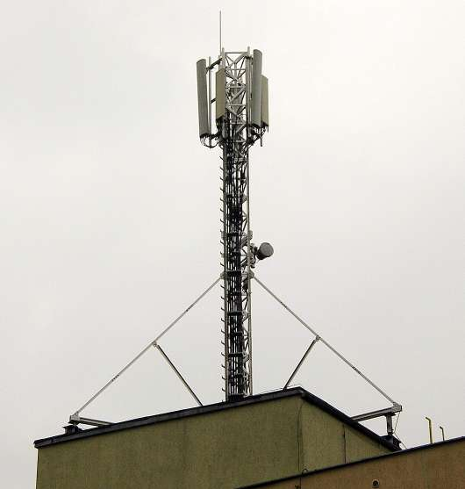
500m
500m

500m
region of strong pollution

Fig. 17.

Next (fig.17), I visualize schematically the reach of the torsion field phantom in the ground due to a 4G base station transceiver of the mobile telecom system. Presently, nobody has a concept for elimination of the phantom that penetrates the Earth to a depth of several hundred metres. It will persist in Earth’s crust for at least several hundred years, harming people, animals and plants.

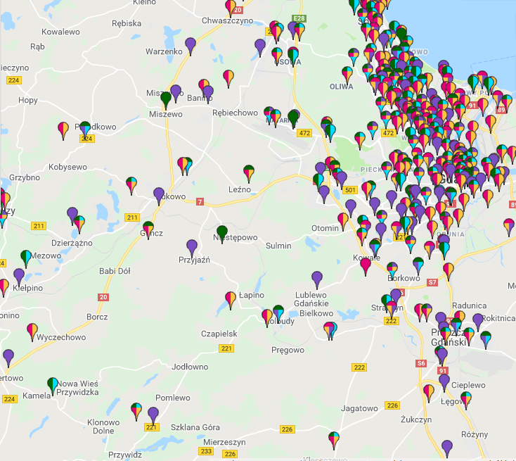

Fig.18

A map of Gdańsk (to the northeast) and adjacent countryside (fig. 18) makes the point that until one can see it, it is hard to realize that cities have such dense networks of base stations. Source: grassroots database of mobile telecom base stations BT.

How to cause tumour epidemic
Receptors sensitive to signal-derived substances and receiving torsionakl fields are responsible for an equilibrium in our body and for all its processes. Chronic illness stems from the activation of regulatory pathways of those processes, not from accidental damage. Using approprietaly selected torsion fields, we can cause a so called afluence disease in someone, undistinguishable from naturally caused illness.
Prescription for a tumour:
Concoct and feed into the body a strong signal characteristic of copper’s torsion field. It activates a kinase Pi3K/AKT/mTOR path. At the same time, give the same body a hormone disruptor, for example water from plastic bottles, that activates the AhR receptor, e.g. bisphenol-A. To boost the signal, it helps to be located in a deep-seated split zone, or to increase the limit for PEM radiation 100-fold, as in the USA where it’s no longer necessary to live in a tectonic split area.

Summary — what’s next

EMF mesurement in no way relates to torsion fields, nor to harm from electric and electronic devices. Present limit guidelines thus have little to do with protecting our health. All proposed costly monitoring systems for EMF intensities make no sense. Perhaps the best indicator of base station transmitters’ harm is the power installed per square kilometre.
EMF screens don’t protect from torsion field, so they must not be recommended to protect health, giving the user a false feeling of safety. In effect, thinking that they are safe leads to still worse exposure to harmful torsion field.
Properly designed mobile telecommunication network can nevertheless operate effectively with thousand time lower radiation compared to present limits. This was shown in a few centres, supporting the argument that there is no need to loosen up the limits for EMF radiation.
It is possible to develop electronic technologies with several times lower emissibility of torsion field, while keeping the emissivity of EMF unchanged. It requires suitable research and application of more complex technology, however. For years, this subject occupies Professor A. Pavlenko in Kiyev.
It is possible to use entirely different types of mobile network, for example in terahertz frequencies that go through rain and tree leaves, as the waves are very penetrating. Alternatively, LiFi system based on infrared spectrum is a thousand times faster than 5G. LiFi example appears in the picture below (fig.19).

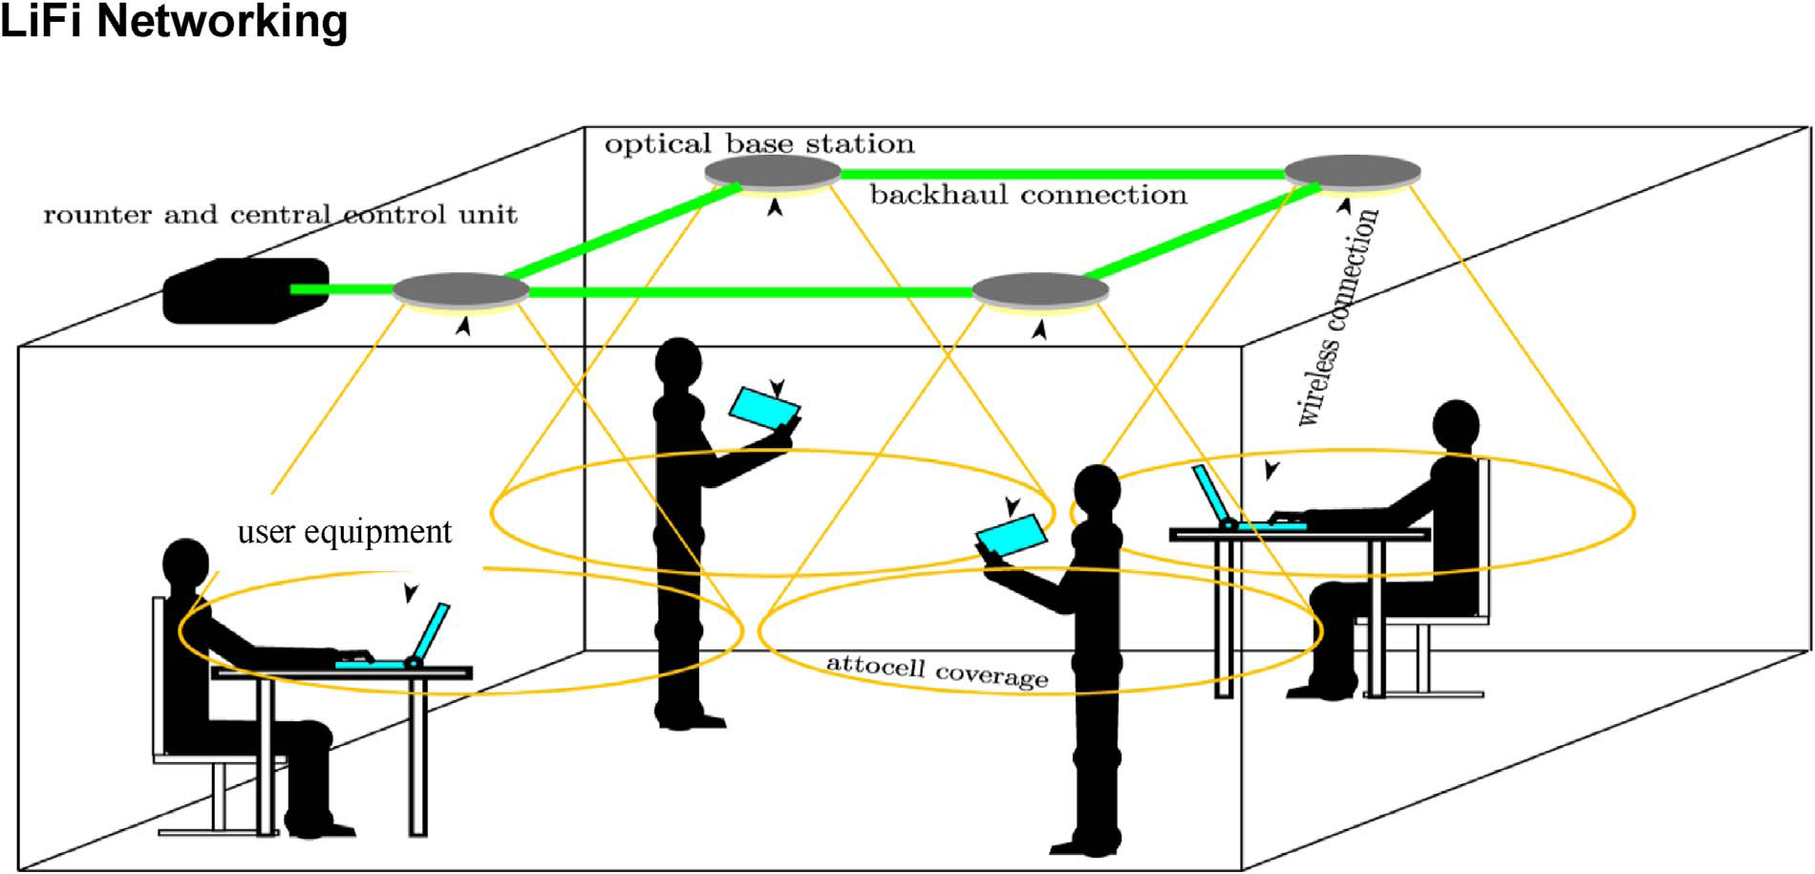

Fig.19.

US officials regard 5G network a strategic weapon. Huawei’s chief said so in an interview for a German magazineon April 17, 2019. He saud strategic, not tactical weapon:
Regrettably, the USA regards 5G technology a strategic weapon. It’s a kind of nuclear bomb for them, said Ren Zhengfei in an interview for Handelsblatt and Wirtschaftswoche.
In building their 5G network, the USA will not let in any foreign company. USA alone is a leader in installing so-called backdoor into their microprocessors. For that reason China and Russia embarked on domestic microprocessor production. A month ago, Iran announced that despite multiple attempts since 2015, they did not succeed in launching any satellites, because of US-made, faulty electronic components — microprocessors as one could guess. We can expect that most of 5G system modules purchased from foreign firms will have backdoors built-in. Whoever would have access to the backdoor, would hold power. Admittedly, the next umpteen years will see a struggle for control over 5G networks, between several groups aspiring to form the world government. We cannot allow to become chess figurines in that struggle.

