WIMPs and biological nuclear reaction in the human body

by Diana Wojtkowiak

Gdańsk, August 18, 2021

Translation: Piotr Bein, authorised by Dr. Diana Wojtkowiak
https://piotrbein.net/2021/08/19/whence-magnetism-at-vax-sites-wimps-and-cold-synthesis-in-the-human-body/

Source in Polish: D. Wojtkowiak; WIMPy i biologiczna reakcja jądrowa w organizmie człowieka, Gdańsk 18 Sierpnia 2021, www.torsionfield.eu http://www.torsionfield.eu/?page_id=413

Abstract

WIMPs, invisible dark matter on the outskirts of galaxies, exert gravitational effects over there. They are also found in the human body, and more specifically in the chakras. They are generated in a biological nuclear reaction, and this reaction is carried out with the use of copper-zinc enzymes. The whole group of copper-zinc enzymes can be treated as having the properties of prions. They are proteins that form a kind of crystals with high mechanical strength and resistance to radiation. They are also torsion field detectors, receiving cosmic cycles, then they use cellular energy, for example from coenzyme Q, to generate high-energy particles, including superoxide radicals, for half a cycle lasting several dozen minutes.
The biological nuclear reaction that produces WIMPs is responsible for numerous paranormal abilities, such as telekinesis, forceless bending of spoons, and attracting ferrous and non-ferrous metals to the body. WIMPs are those reaction particles that are suspected of interacting with non-ferrous metals at a distance and of cold-melting metals. Study of people vaccinated with COVID-19 vaccines shows that the vaccinated are strongly activated the same copper-zinc enzyme usually found in the heart chakra. The enzyme is dispersed over a large part of the body in people with a natural ability to attract metals. Hence, it is not surprising that most people vaccinated with the experimental vaccine in the injection area, or over a large area of ​​the body, show attraction to ferrous and non-ferrous objects.

Introduction

Para-psychic and paranormal phenomena go beyond the modern molecular physicists and biologists’ understanding of the world. Telekinesis, levitation and cold melting of metal cannot be explained by electromagnetism, nor by torsion fields and their particles, which do not transmit energy but only information. Hence, forceful para-psychic phenomena invite a deeper search into unknown areas of physics. I found a way to solve the puzzle accidentally, while trying to check whether the slow neutrinos on the outskirts of galaxies, postulated ¹ as dark matter, are present over there in large numbers. Indeed, there are many of them at a distance several times greater than the radius of the galaxy as seen through a telescope. This is a huge distance: several dozen kps (1kps = 3,26 thousands of light-years). There are also quite a few neutrons over there, though, and we know very well that neutrons only live 15 minutes, turning into protons, electrons and neutrinos. Consequently, intense nuclear reactions go on over there. The neutrinos that are formed in the decay reaction escape at nearly the speed of light. This is not dark matter, though. Near the end of the torsion field particle spectrum, which takes two days to measure, something very heavy reveals itself where artificial elements occur, not the natural ones. However, it is hard to expect loads of artificial elements in the cold space beyond the galaxy!
Another candidate for dark matter are heavy elementary particles have for years been electromagnetically intert, weakly- and gravitationaly-interacting WIMPs (Weak Interaction Massive Particles).² Their proposed mass is several to several hundred times that of protons. This definition encompasses more than one theory, and therefore more than one hypothetical particle. Such particles have appeared in my experiments as real, or even tangibly existing and acting forcibly, being not only in outer space, but here on Earth, even in our body. Where do free elementary particles in our body come from? Were they caught from the environment or made in our body?
K. Kervran ³ described many experiments showing the transmutation of elements in plants and chickens. According to mid-19th century experiments, plants are able to transmute elements that they need. In soil too poor in magnesium for chlorophyll production, plants grow by consuming virtually all of the magnesium available in the soil. After harvesting all the plant mass, the yield is similar the following year. After ten years of taking the plant mass, the plants can still cope without magnesium in the soil. Similarly, plants can produce other important elements they need. Chickens on a calcium-free diet are able to produce normal eggs with a calcium carbonate shell. For example, when they get silicon-rich oats, the silicon is converted into calcium. Dried fruit contains about half the minerals of fresh fruit.³ Also J. Biberian described many works by various authors, as well as his own, showing the transmutation of elements in plants, bacteria, yeast and even in mice.^{4, 5} Are humans also able to carry out biological nuclear reactions? By taking a torsion field particle signal from an average person, for example from the side of a finger, one can see the signal from electrons, which may come from aromatic amino acids, for example, but not from other elementary particles.
After this introduction, we can now move on to experiments, they will be easier to grasp.

Experimental part

Methods

In this work I do not deal with torsion field particles nor torsion fields, but I use them as an excellent carrier of information about particles that do not interact electromagnetically. My previous research shows that due to the universality of torsion fields in the structure of matter, basically all elementary particles interact with torsion field particles and can be observed in respective spectroscopy. Such a spectroscope was developed by me and my colleagues a few years ago and there is currently no equivalent in civil scientific research in the world, to my knowledge. The instrument provides a large amount of information unobtainable by other methods. The neutrinos named above are detected by torsion field particles as readily as all other elementary particles are. The spectroscopy of torsion field particles has been described.⁶
The second important device is the torsion field accelerator. It enables the acceleration of the torsion field particles, and thus their transfer from the source to the carrier, or from one carrier to another.
Research becomes much easier when the information carried by the torsion field particles is transferred through photographs, especially, when is printed on polyester film. The torsion field particles have no mass and at the same time have some affinity with other particles. Torsion field particles travel from a distant galaxy stuck to photons of visible and infrared light. They can pass on photons through the optics of cameras or telescopes, then free themselves from photons on the photographic film, binding to it. Electronic cameras also transmit torsion field particles. The image with the information contained in the torsion field particles can be further transferred via the Internet. This makes it possible to use any photos, except those printed in newspapers or books, in order to obtain much more information than with our eyes. The signal to noise ratio is usually very good. The mere extraction of non-optical information from photos for apparatus research has been used for 100 years. Albert Abrams, a pioneer in the construction of radionics devices,⁷ was the first to do this.

WIMPs in space

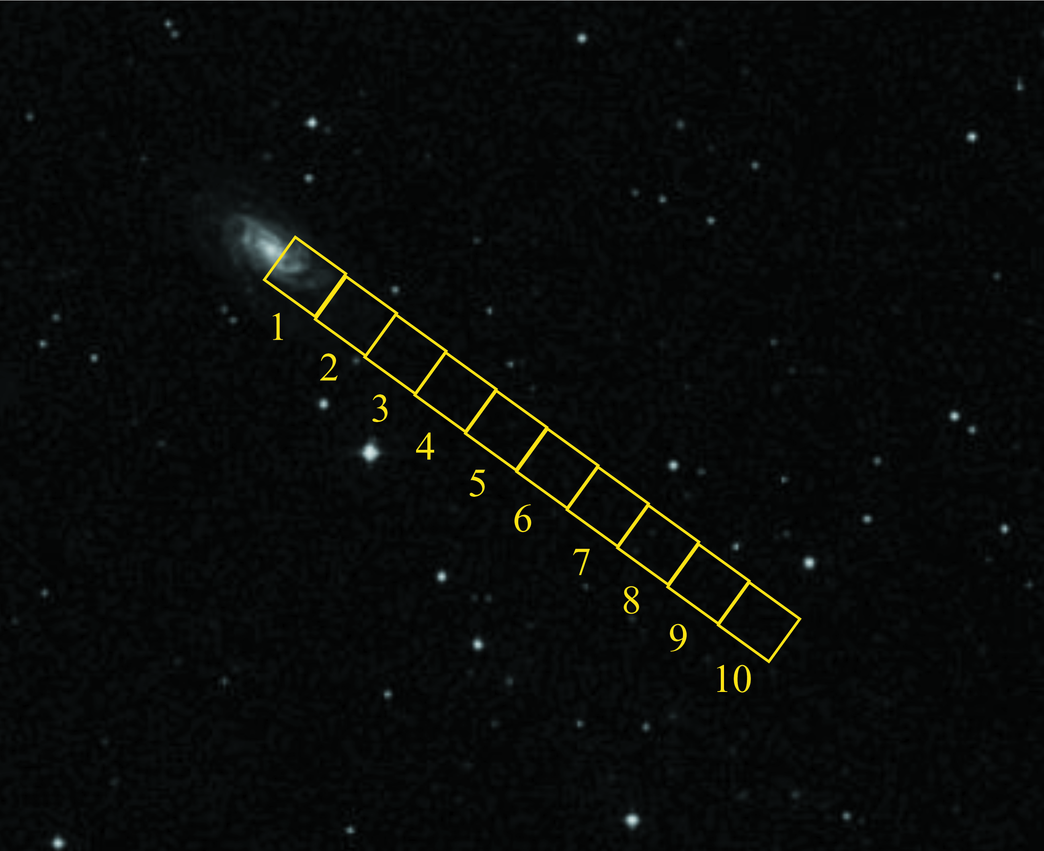
Parkhomov¹ suggests that neutrinos are dark matter’s main component. I didn’t need to believe his argument. as I could check it with torsion field particle spectroscopy. Previously, I checked the thesis from his other theory ⁸ that a metal heated to several thousand degrees must emit neutrinos, which he could not verify experimentally. Indeed, the tungsten filament bulb, especially when subjected to excessive voltage, turned out to be neutrino source.
From an Internet photo of galaxy NGC 2998, where the presence of dark matter1 has been well established by astronomers, rectangles outlined in Fig. 1 were cut out. The signal of torsion field particles from the rectangles was transferred to water vials, and then examined with a spectroscope.

Fig. 1. Spiral galaxy NGC 2998, https://theskylive.com/sky/deepsky/ngc2998-object

Fig. 2 shows elementary particles and elements spectrum for rectangle 5 of Fig. 1. This field was selected after preliminary probing for the highest level of the neutrino signal, as well as the highest total torsion field particle signal. ⁹

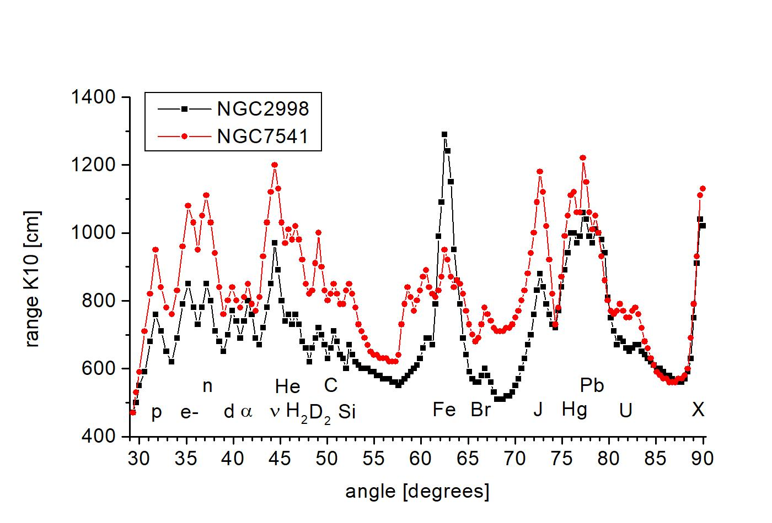
Fig. 2. The full spectrum for rectangle 5 marked in the photo of galaxy NGC 2998, corresponding to the maximum presence of dark matter, and also for the analogous rectangle 6 of galaxy NGC 7541. Markings: p – protons, e – electrons, n – neutrons, d – deuterons, α – alpha particles, ν – neutrinos, He – helium, H₂ – hydrogen, D₂ – deuterium, C – carbon, Si – silicon, Fe – iron, Br – bromine, J – iodine, Hg – mercury, Pb – lead , U – uranium, X – unknown signal. Horizontal axis: incident beam angle relative to the breaking plane, in degrees. Vertical axis: K10 Category radiation range from samples at the output of the spectroscope, in cm. ⁹

In the spectra for the periphery of the two galaxies, we can see that there are quite a lot of neutrinos over there. But there are also neutrons. They live only 15 minutes, decaying into protons, electrons and neutrinos, and more specifically - anti-neutrinos. Here, however, we cannot distinguish neutrinos from anti-neutrinos; for conveniece we define neutrinos broadly. Protons and electrons are visible, too. At the very end of the graph, at the limit of the spectroscope’s resolving range, a peak appeared, which could correspond to an artificial element exceeding plutonium mass. However, we do not expect artificial elements in outer space. This, however, could be another dark matter candidate, the so-called WIMP (Weak Interaction Massive Particle) - a hypothetical elementary particle with a mass of several to several hundred proton masses, acting by gravity and weak interaction, and not exhibiting any electromagnetic interactions. Scientific theoretical publications abound on the subject. ^{2,10,11,12} Actually, WIMP is a common name for several particles of slightly different properties.
The discovered WIMPs are even further from the galaxy center than neutrinos or iron are. This is shown in Fig. 3 taken from article ⁹; the strongest signal from WIMPs occurs at a distance of five radii of galaxy NGC 2998 observed in visible light.

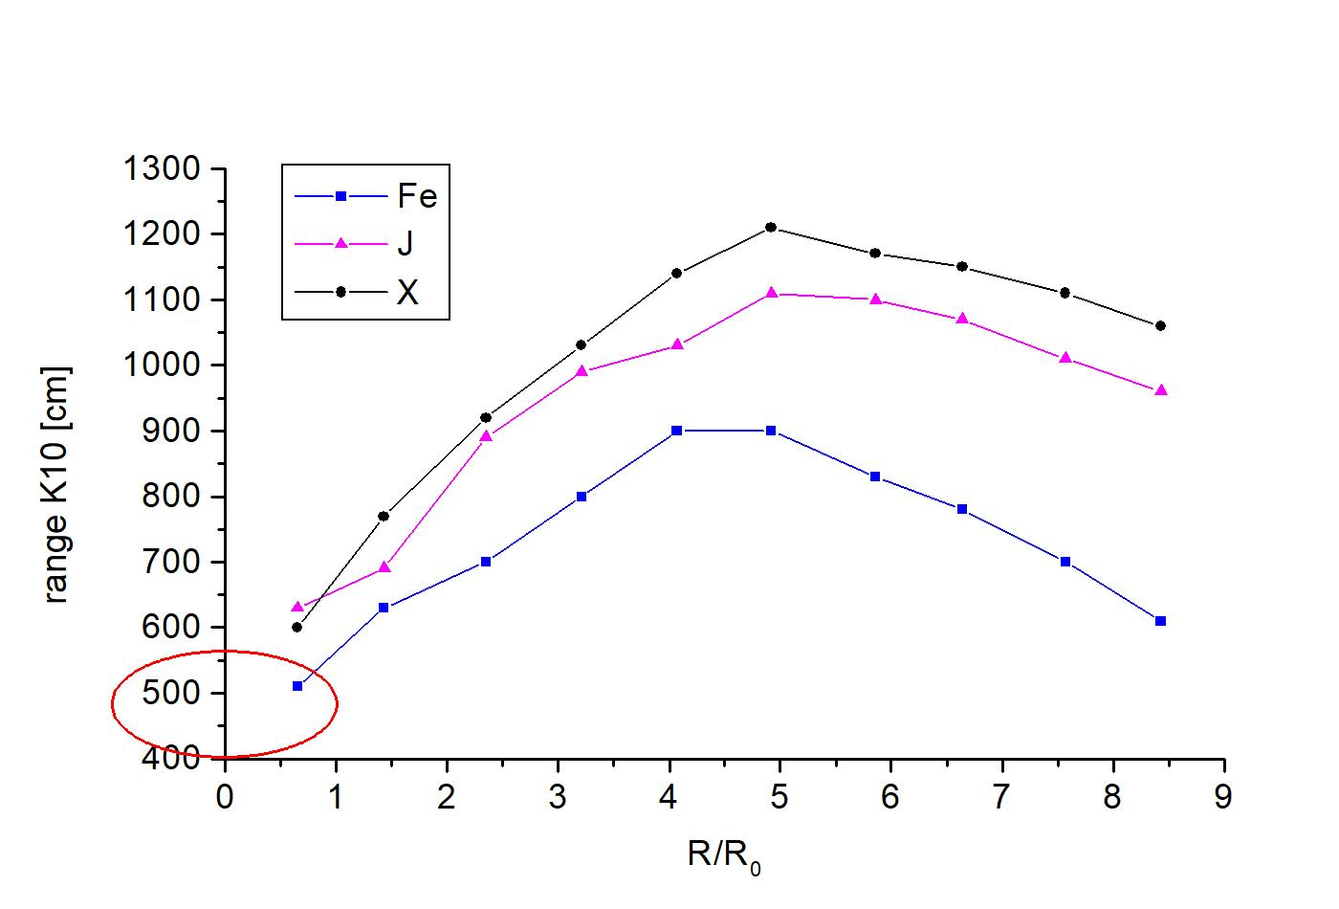
Fig. 3. The intensity of signals from galaxy NGC 2998 photo as a function of distance from galaxy’s center. Blue squares – iron (Fe) signal, purple triangles – iodine (J) signal, black circles – signal of unknown substance X at the very end of the curves in Fig. 7. Relative individual signal values were retained. A symbolic ellipse at point zero of the chart shows the optical size of the galaxy. Horizontal axis: ratio of the distance of the measurement rectangle center from the galactic center to the galaxy radius. Vertical axis: K10 Category radiation range from the samples at the output of the spectroscope, in cm. ⁹

As such particles are located on the outskirts of the galaxy. Why not try to find them here on Earth, also in our bodies? We need at least two new particles to understand unexplained phenomena in the functioning of human body. One particle concerns the subtle matter responsible for creating impressions of our consciousness called qualia in philosophy. This is a known problem of psychophysical duality. When we dream about something, no light is produced in the brain, and feelings have no equivalent in the known physical world except for the psyche. The second, less subtle, particle is needed to explain paranormal force phenomena such as telekinesis, levitation, and the bending of spoons. As they do not transmit energy, but only information, torsion field particles cannot effectuate force phenomena. They are associated with bioenergy therapy and telepathy, but they do not directly influence what shows up in our consciousness. They could highly probably be WIMPs in force interactions. Where to look for them in our body? Perhaps in the radiation of the chakra located on the top of the head, being associated with the cosmos the most?
First on myself, then on a friend, holding a vial of water on the top of the head for 30 seconds, then checking on a spectroscope for a WIMP signal, the simple experiment showed that it really is there. The friend “control” sample served to eliminate the possibility that operating with the spectroscope, I could irradiate myself more with the signal from galaxies. Detailed results of this short experiment appear under “Chakra 1” below.

Teaspoon


The bending of spoons is a good example of forceful paranormal phenomena. I keep one of the seven spoons that my friend (S. A. W.) from Gdańsk bent in my presence between two fingers in three separate sessions (Fig. 4). He said at the time that now he had the power, lifted the spoon horizontally while holding it with two fingers, and the ends of the spoon fell gravitationally after at most a dozen or so seconds. It was as if the metal had cold-melted between his fingers. This is not a struggle of Uri Geller’s, who in the old film, when he was still a boy, placed a spoon in a vice, stroked it, focused on it, so that it would finally bend by thirty degrees, after several minutes’ effort.

Fig. 4. A stainless steel spoon bent in year ca. 2000, by Gdańsk resident, S. A. W. with paranormal abilities. This person lost this ability over time.

As the hardening glass remembers the torsion field information from the environment¹³, presumably the hardening metal, or even the metal in general, would store high intensity field information. Indeed, the signal taken from the bend of a spoon, where it was held with two fingers, contains a large amount of information. The signal from the spoon was copied with a torsion field accelerator onto the water vial and split, using a torsion field particle spectroscope. The spectrum appears in Fig. 5.

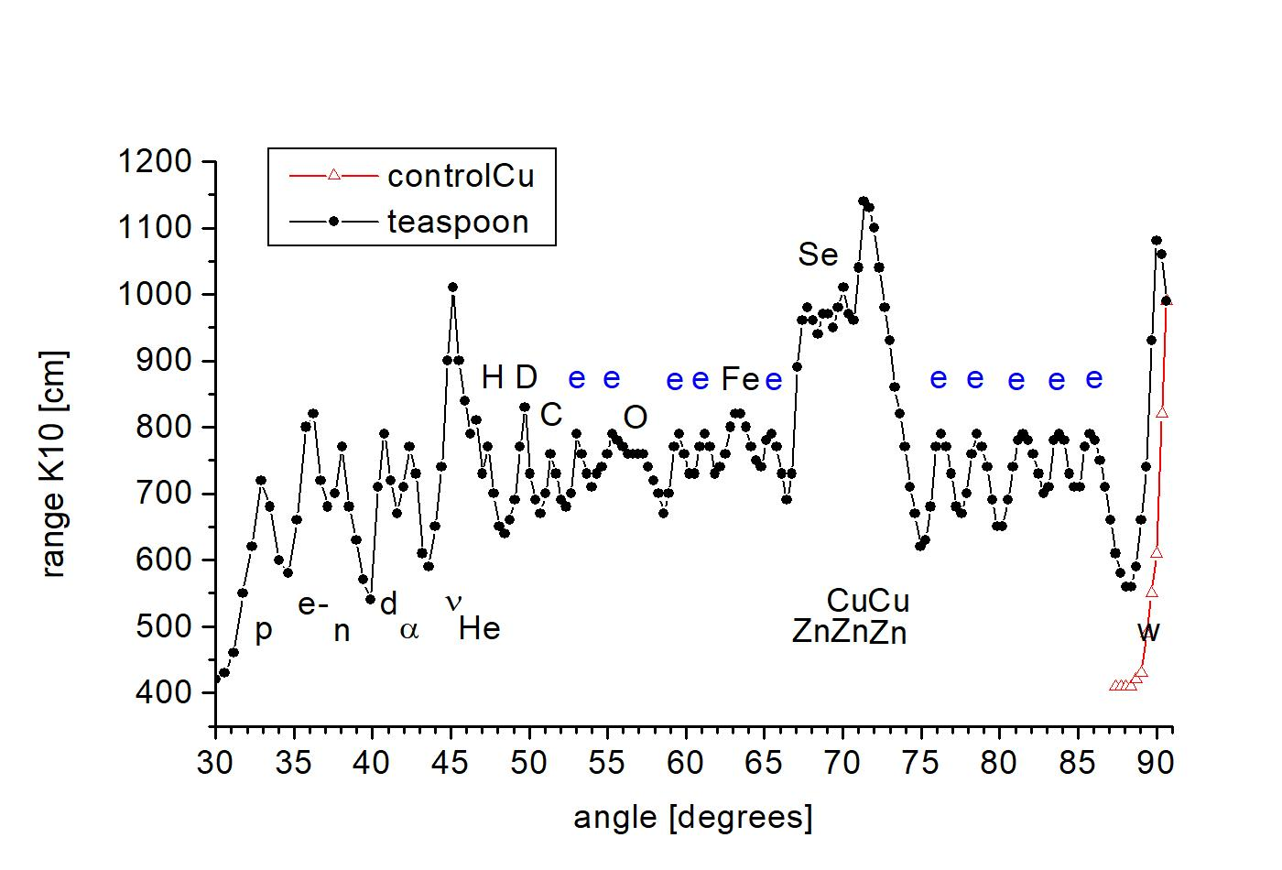
Fig. 5. Spectrum of the signal obtained from a stainless steel spoon bent with the use of paranormal abilities. The red line marks the background level of the spectroscope, as the WIMP peaks near the limit of the measuring range. Markings: p – protons, e- – electrons, n – neutrons, d – deuterons, α – alpha particles, ν – neutrinos, He – helium, H – hydrogen, D – deuterium, C – carbon, O – oxygen, Fe – iron, Cu – copper, Zn – zinc, Se – selenium, w – WIMPs. e – signal from aromatic amino acid rings. Horizontal axis: angle of the incident beam relative to the breaking plane, in degrees. Vertical axis: K10 Category radiation range from samples at the output of the spectroscope, in cm.

The chart indicates the presence of WIMPs and biological cold fusion or biological nuclear reaction in which deuterium takes part in water as a trace substrate. The neutrinos, helium-4 and the WIMPs are formed, but the type of nuclear reaction is not obvious. Since we have a proportion of one deuterium atom in several thousand hydrogen atoms in water, we would expect it to react with hydrogen to become helium-3. However, being an unusual product of nuclear reactions, helium-3 is absent. Particle α with its high symmetry and resulting energetic preference, will select electrons from the environment to become normal helium. We do not know where the missing neutron was taken from - maybe from a metal in the enzyme that produces the biological cold synthesis reaction, or a slightly different reaction. The third element, and the most interesting one, is the written information about the protein enzyme, a catalyst in the nuclear reaction. It’s a copper-zinc enzyme. There are not many such enzymes, several dozen are known, with thirty thousand genes in our body. The area we are looking for is therefore very narrow. Additionally, the selenium signal is visible. This means that there is selenomethionine or some modification of it in the enzyme. It is not one of the essential amino acids. In this case, sulphur in methionine is post-translationally converted into selenium with the use of appropriate cellular equipment. This further narrows the sought area. This will call for determination of individual copper-zinc enzymes from the protein sequence, which contain the code for the conversion of sulphur to selenium. We can’t always find in published information on specific proteins, if testing for selenium presence was done. The small amount of aromatic signals marked with e indicates a signal from one protein, or rather from the active domain itself.
Copper-zinc proteins are not new to me. Working in biotechnology together with Dr. Jolanta Grzenkowicz-Wydra (then a graduate student), we developed a method of obtaining human copper-zinc superoxide dismutase from a gene introduced into Pichia pastoris yeast. The preparation exhibited twice the specific activity in the removal of superoxide radicals compared to a commercial one by Sigma, a global controller of the reagent market. Given a significant concentration of the enzyme after washing it out of the chromatography column, it was easy to discern fractions it was in - they were light blue, due to divalent copper.
The second enzyme tested was NADH-oxidase CNOX partially purified from milk straight from the cow. The enzyme is unique, a “cosmic clock” whose 24-minute cycle is independent of temperature. It creates oxidative conditions in the cell for 12 minutes, breaking the disulfide bonds in proteins, and reducing conditions to re-bind the disulfide bridges for another 12 minutes.¹⁴ This way, a cell with a rigid protein cytoskeleton can grow. This protein is likely to receive a synchronizing signal from environmental torsion field, easily detectable by torsion field measurement methods. The resulting preparate exhibited such a 24-minute cycle. The third group of known copper-zinc proteins are the prion and the prion-like proteins. Literature does not name any use of the prion in the body. Twenty years of intensive research have failed to produce reasonable results ¹⁵ and deletion of the prion’s gene in mice does not significantly impair them, even after fifteen generations. After all, no one considered that it could conduct biological nuclear reactions and produce WIMPs that are not needed for normal physiology, but rather for paranormal phenomena. Humans used paranormal phenomena more commonly in the old days.
These three groups are not completely separate. Copper-zinc superoxide dismutase has some prion-like properties, and some prion-like proteins are also cosmic clocks, e.g. synuclein that gets damaged in Parkinson’s disease, Aβ amyloid deposits in Alzheimer’s disease, or the PrP prion protein itself. ¹⁶

Nina Kulagina

Let’s check out an example of telekinesis. With several paranormal abilities, Nina Kulagina was an interesting person in the Soviet Union. A special research unit was established to study the Kułagina phenomenon. After ten years of work, the unit concluded that Kulagina had been deceiving them all the time, while lacking any paranormal abilities. A different conclusion was impossible in USSR. Fig. 6 shows a film frame when Kulagina pushes a metal cylinder (probably empty) from a distance.

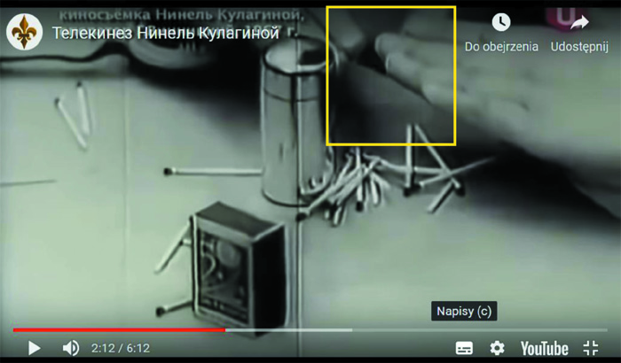
Fig. 6. A frame from the film at the moment when Kulagina pushes a metal cylinder from a distance. Телекинез Нинель Кулагиной https://www.youtube.com/watch?app=desktop&v=uO6Zevg-gYs

Fig. 7 presents torsion field particle spectrum from the rectangle marked on the frame covering the space between Kulagina’s cylinder and fingers, and also the tips of her fingers.
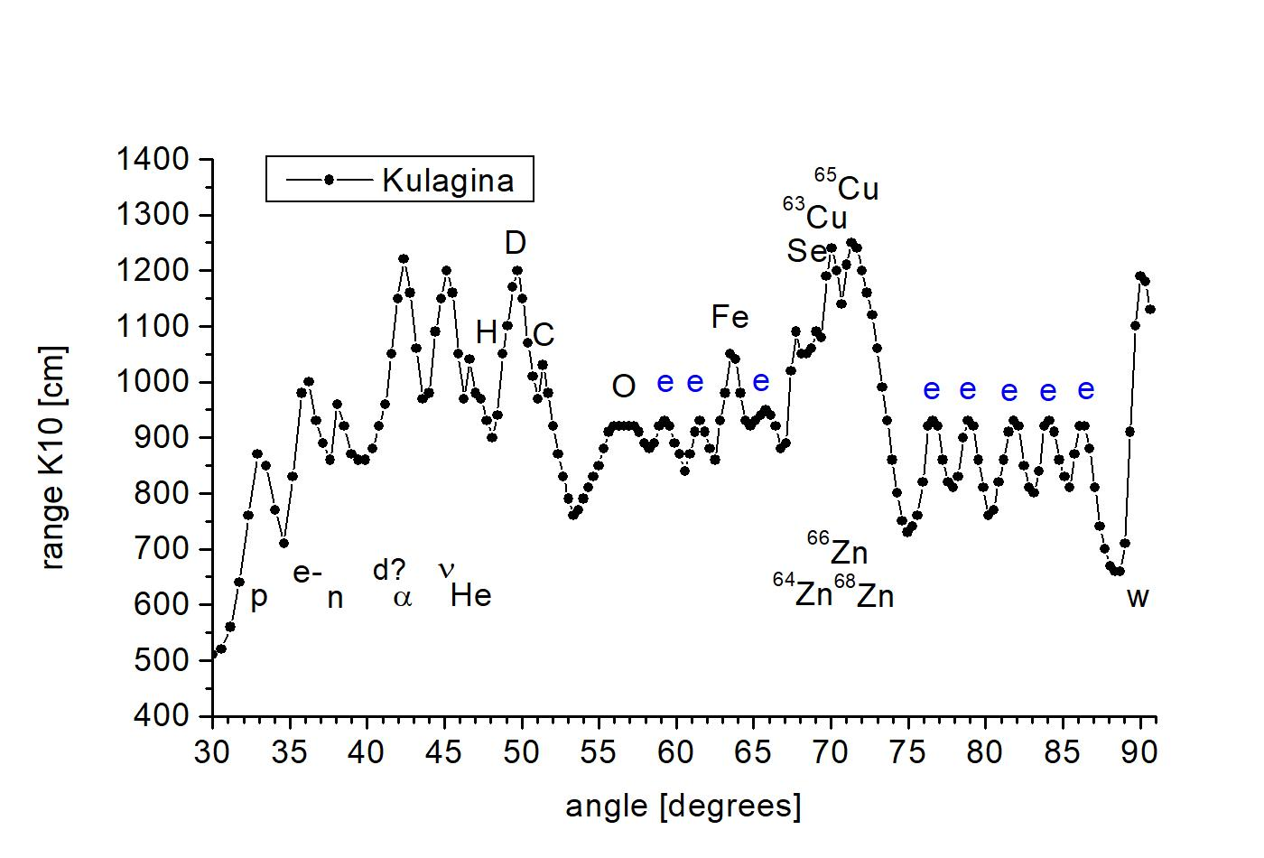
Fig. 7. The spectrum of the signal from the marked area of ​​the frame of the film about Kulagina, when one could expect information about radiation related to telekinesis. Markings: p – protons, e- – electrons, n – neutrons, d – deuterons, α – alpha particles, ν – neutrinos, He – helium, H – hydrogen, D – deuterium, C – carbon, O – oxygen, Fe – iron, Cu – copper, Zn – zinc, Se – selenium, w – WIMPs. e – signal from aromatic amino acid rings. Horizontal axis: angle of the incident beam relative to the breaking plane, in degrees. Vertical axis: K10 Category radiation range from samples at the output of the spectroscope, in cm.

The spectrum shows the presence of components of the analogous biological nuclear reaction, WIMPs, and probably the same copper-zinc protein as before.

Chakra 1

Let’s return to the chakra located on head’s top. I define it as chakra 1 or more precisely K1, based on the experimental examination of the Categories (radiesthetic colorus, zodiac signs) radiated by the main chakras, using metallic patterns held in the hand. In this way, on the head’s top we find Category 1, on the forehead Category 2, on the larynx Category 3. In the fovea below the larynx, we find Category 4 chakra, unnoticed by most authors, and Category 5 chakra shifted to the left in the area of ​​the heart, at the site of the solar plexus Category 6 radiating chakra, under the navel Category 7 radiating chakra, in the lower abdomen area we find Category 8 radiation, while on arm and leg joints we find Categories 9 to 12. The description of the psychological properties of the seven popular chakras taken from Eastern sources is consistent with the Categories or signs of the zodiac that I have assigned.
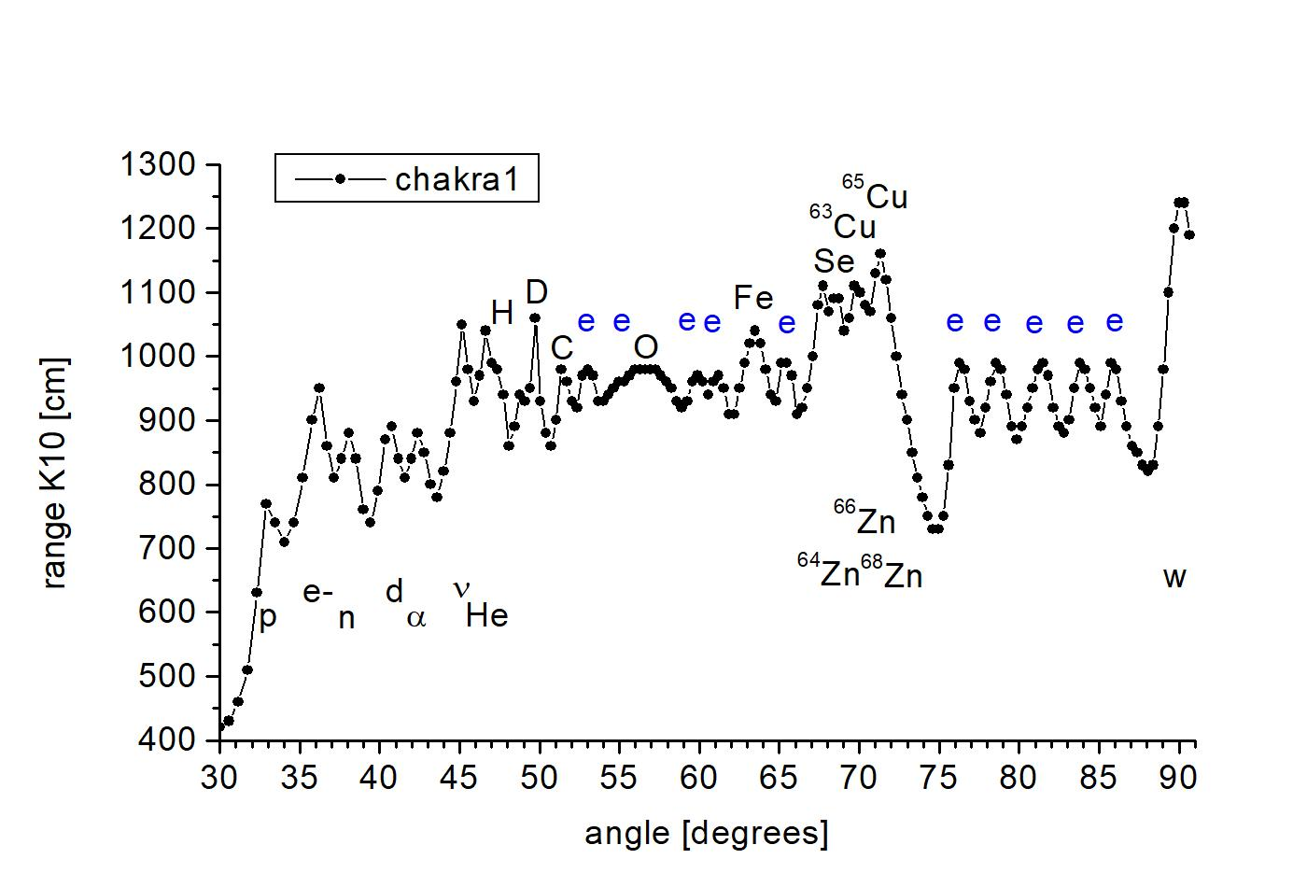
Fig. 8. Torsion field particle spectrum from top of the head chakra of W. M. from Gdańsk, a person without paranormal abilities. The water vial was held for 20 seconds on the top of the head with a protection so as not to add radiation from the fingers, the vial was then placed in the spectroscope. Markings as in the previous two charts.

Fig. 8 presents chakra 1 spectrum from my colleague W. M. from Gdańsk, who does not have any noticeable paranormal abilities. Beside WIMPs, there is a nuclear biological reaction in this area, under normal conditions without any focus on the chakra. The reaction is probably run by the same enzyme as in previous measurements. It is no accident that the small end of the thumb chakra is associated with the top of the head chakra.¹⁷ Several chakras (1, 2, 5) and eye chakra I examined on three people in 2015, showed differences in the pattern of signals between the chakras and at the same time a high similarity for the three people. The study was carried out on a preliminary version of the spectroscope, in which diffraction had not yet been eliminated, but the overall relationship was not in doubt.
Torsion field particle spectrum from places on the body that are beyond the influence of the chakras such as the arm, side of the finger and blood does not suggest any presence of biological nuclear reaction - see Fig. 9.
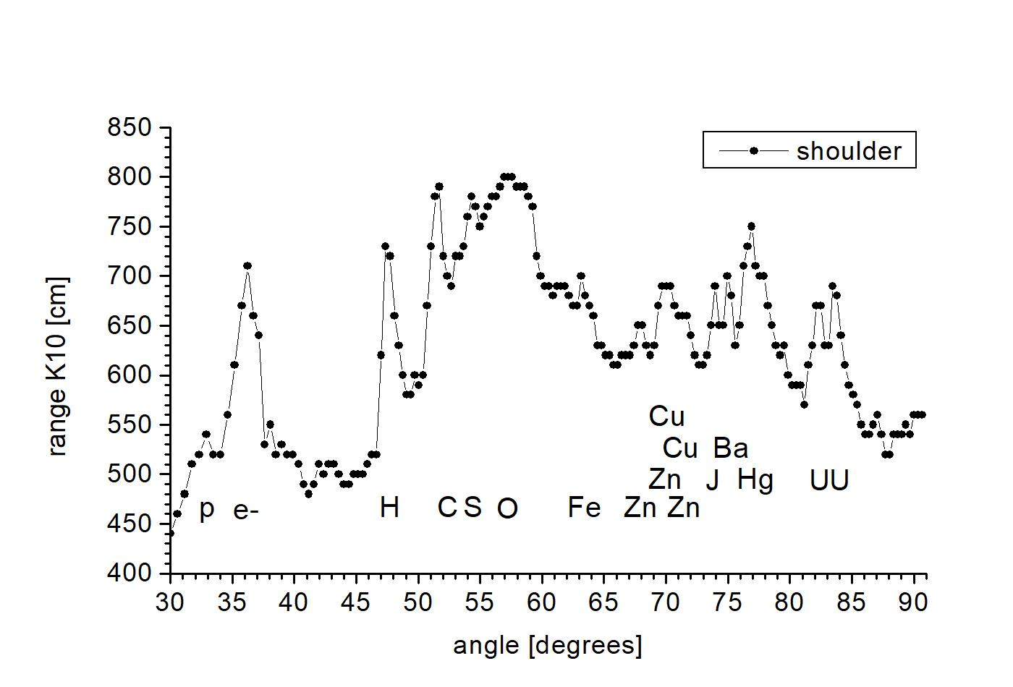
Fig. 9. Spectrum of the signal collected into the vial from the arm of W. M., a person without paranormal abilities. Vial exposure time 20 s. Markings p – protons, e- – electrons, H – hydrogen, C – carbon, S – sulphur, O – oxygen, Fe – iron, Cu – copper, Zn – zinc, J – iodine, Ba – bar, Hg – mercury, U – uranium. Horizontal axis: angle of the incident beam relative to the breaking plane, in degrees. Vertical axis: K10 Category radiation range from samples at the output of the spectroscope, in cm.

Fig. 9 shows that outside the chakras, on the arm, there is no biological nuclear reaction, no WIMPs, and no dominant presence of the copper-zinc enzyme. Iodine, barium, mercury, and uranium signals come from the environment, the sun, and Earth’s interior radiation recorded at the time of birth, conveying a person’s astrological characteristics in a Category system.

The natural ability to attract metal objects

Another paranormal ability manifests itself in the phenomenon of all kinds of metal objects sticking to the body of some people referred to as people-magnets. The term leads to a dead end as there is no magnetic field here. There are no magnets in the body, and attraction is not limited to ferromagnets. Various metals are attracted, e.g. brass or aluminum, but also plastics, wood and even glass. After all, a child knows that out of the most common substances, magnets attract only iron. The repeated mistake shows widespread infantilism where curiosity should arise: what is it that non-iron objects are attracted to. Usually only certain parts of the body exhibit the attraction.
In the area of the chest, a person I have met, B. S. from Gdynia, for 30 years has been able to attract spoons and various objects made of magnetic and non-magnetic metals, abdomen and arms. The effect has an impact on the physiology; the body is elastic and does not easily yield under pressure in these areas. This effect is completely absent on the calves. Fig. 10 shows the natural attracting of metal objects by the person.


Fig. 10. Various ferrous and non-ferrous (non-magnetic) objects adhering spontaneously to the tested woman’s (initials B.S.) body. On the left edge of the photo: a polycarbonate plate 10 mm thick and a brass plate 4 mm thick.

Fig. 11 shows torsion field particle radiation spectrum from the woman. As radiation centre appeared to lie in the vicinity of the heart chakra, the information of the torsion field particles was captured from where the heart chakra is located by putting a bottle of boiled water on it for three minutes. Additionally, a signal was taken from the arm, i.e. where there are no chakras. A strong signal in the bottle was needed so that it would not be disturbed during the transport to the laboratory. Later, the signal was repeatedly attenuated to the requirements of the spectroscope.

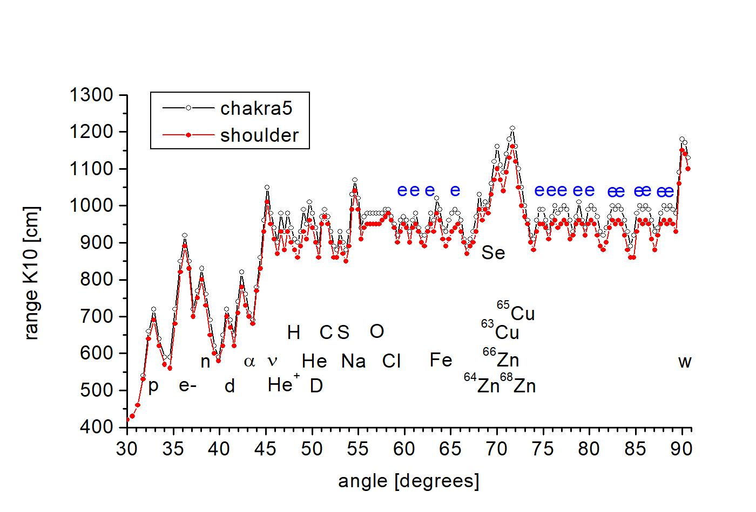

Fig. 11. Torsion field particle signal spectrum taken from heart chakra area and from the arm of a person with the natural ability to attract metal objects. Markings: chakra5 – heart chakra signal, shoulder – shoulder signal, p – protons, e- – electrons, n – neutrons, d – deuterons, α – alpha particles, ν – neutrinos, He ⁺ – ionized helium molecule, He – helium , H – hydrogen, D – deuterium, C – carbon, S – sulphur, O – oxygen, Na – sodium, Cl – chlorine, Fe – iron, Cu – copper, Zn – zinc, Se – selenium, w – WIMPs , e – signal from aromatic amino acid rings. Horizontal axis: angle of the incident beam relative to the breaking plane, in degrees. Vertical axis: K10 Category radiation range from samples at the output of the spectroscope, in cm.

Fig. 11 shows the presence of WIMPs, a biological nuclear reaction and the biogenic elements of the copper-zinc enzyme. The signal pattern to the right of the enzyme’s aromatic rings indicates a different enzyme than the one responsible for bending spoons. The chakra and arm charts are identical, which means that the presence of the copper-zinc enzyme responsible for the biological nuclear reaction and the production of WIMPs is no longer confined to the heart chakra, but is spread over a large part of the body.

Chakra 5

In order to verify that the examined phenomenon spilled over the body can actually be related to the heart chakra, the radiation of the heart chakra of a person (W. M.) without extraordinary paranormal abilities was examined. Fig. 12 shows radiation from the heart chakra (chakra 5) shifted by about 3 cm from the body axis. The graph is very similar to the graphs from a person having the natural ability to attract metal objects. There is a biological nuclear reaction, WIMPs are visible and we can assume that we are dealing with the same copper-zinc enzyme.

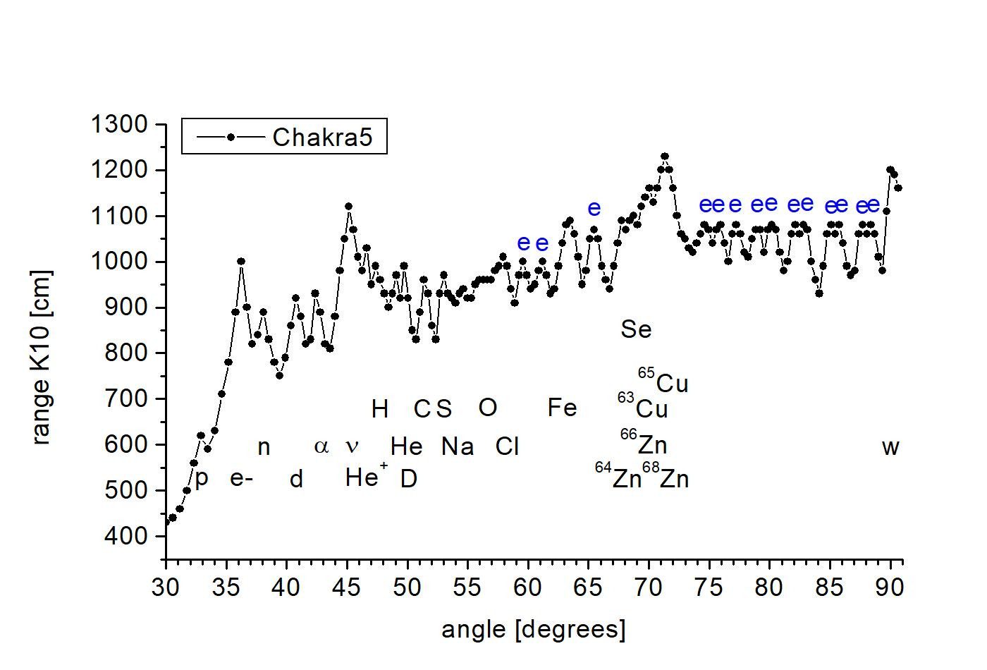
Fig. 12. Signal spectrum of chakra 5 from reference person W. M. Markings as in the previous figure.

COVID-19 vaccines

As we already know from many Internet reports, some people vaccinated with the COVID-19 vaccine, show as a vaccine effect the magical phenomenon of attracting metal objects to the arm to which the vaccine was administered, and in extreme cases to the entire body. This effect is related to a pre-planed marking of vaccinated persons, so that the fact of vaccination can be checked with airport equipment, regardless of the vaccination certificate held. Recently, people who traveled by air have noticed that terahertz scanners for screening travelers have recently been turned off.
I examined the radiation spectra of torsion field particles from the arm of two people vaccinated with the COVID-19 vaccine, who showed spontaneous attraction to metal objects, but had no such ability before. Fig. 13 shows these two people with scissors stuck to their arm. The first person is an Italian from Sicily who was vaccinated in his country with the Moderna vaccine. The second person is a Polish woman living in London, vaccinated there with the Pfizer vaccine, who just came to Poland. In the first case, the spectrum was taken from a film frame made especially for this article by Jarosław Dobrucki. In the second case, the signal was collected by placing a vial of water against the inoculated arm for three minutes.



Fig. 13. Photos of two people vaccinated with Moderna (left) and Pfizer (right) vaccines, showing the attraction of metal objects. The rectangle is a brass plate 4 mm thick, i.e. non-magnetic. Similarly, in the first case, there was attraction of non-magnetic metals, e.g. 10 Euro cent coins, which were not attracted by a magnet.
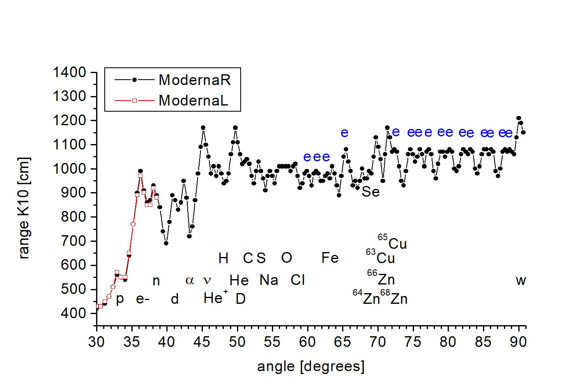
Fig. 14. Radiation spectrum from the arm of a person vaccinated with the Moderna vaccine. ModernaR (black dots) signal from the right arm that received the vaccine. ModernaL (red open squares) signal from the left arm. Other markings as in Fig. 11.
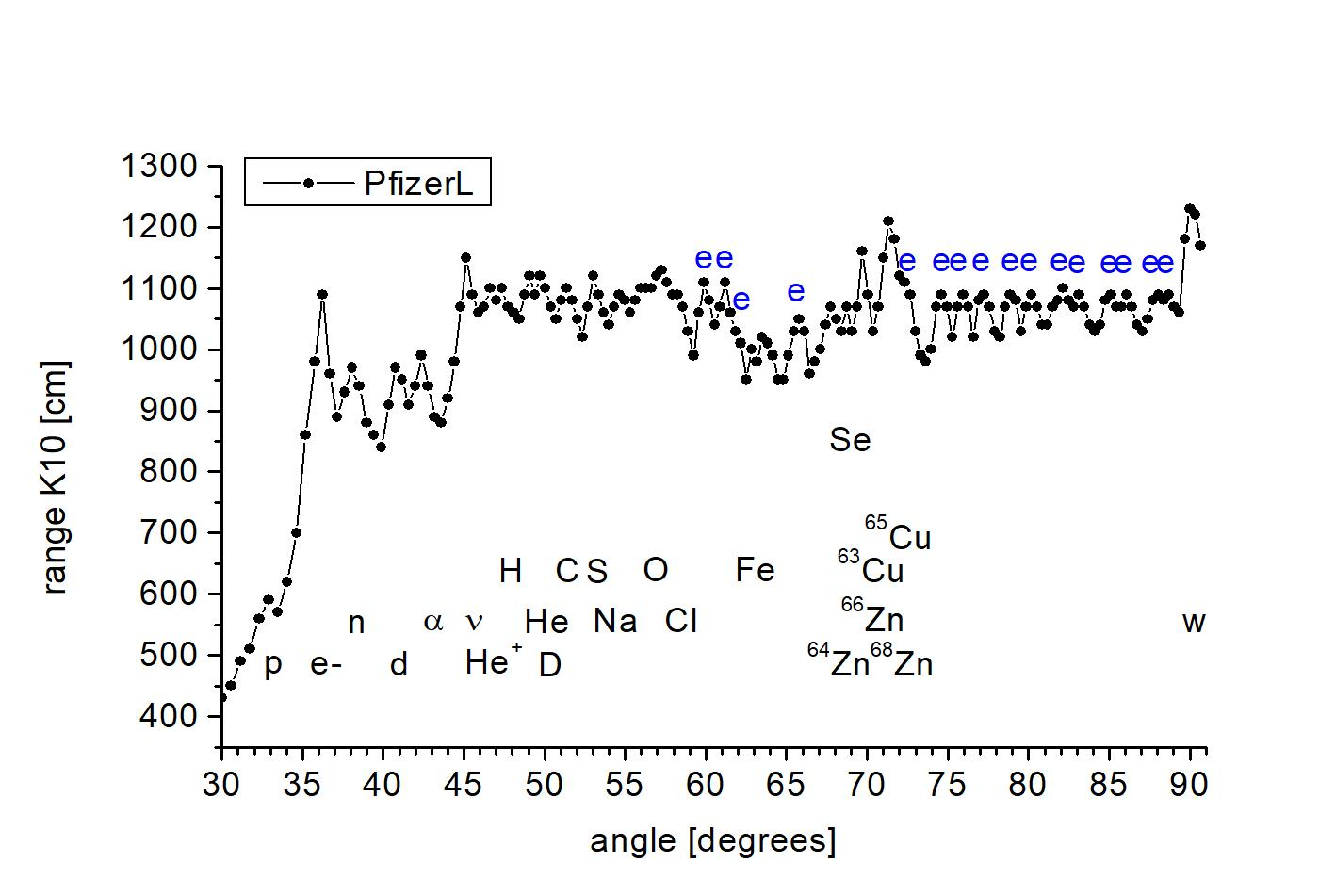
Fig. 15. Radiation spectrum from the left arm of a person vaccinated with the Pfizer vaccine. Markings as in Fig. 11.

Fig. 14 and 15 show that in the Moderna and Pfizer vaccines, the same copper-zinc enzyme is activated in the body, i.e. of the same pattern of signals from aromatic rings in the angular range 72° -82° in the graph, specific to a particular copper-zinc bound enzyme with a specific chakra. The same enzyme occurs in a person with the natural ability to attract metal objects and at the same time in the K5 (heart) chakra of a person without exceptional paranormal abilities. In both cases, there is a biological nuclear reaction and WIMPs responsible for attracting metals are present.

Summary

This work serves to explain the physical and biological phenomena opccuring in the case of three selected paranormal phenomena: bending spoons, pushing away metal objects and attracting metal objects to the body. In all these cases, the following was found:
- The presence of a biological nuclear reaction.
- The presence of dark matter particles with previously undescribed properties on a macro scale.
- The presence of a copper-zinc enzyme involved in the nuclear reaction.
The subject of paranormal force phenomena has been of great interest for many years, as we are not dealing with electromagnetic interactions, which any reasonable researcher will dismiss here as having no ability to attract non-ferrous metals or soften the structure of the metal. It is bad that many physicists, deprived of a ready-made textbook solution to such topics, pretend that such phenomena do not exist. Electromagnetic interactions are already thoroughly known, also longitudinal electromagnetic waves, there are no more areas with some unpredictable properties. Thirty years ago, the terahertz range was such a mysterious area, where we were not able to generate electromagnetic waves. Today, this range is technically mastered and used. There are no breakthroughs regarding the properties of these waves. Therefore, it is necessary to explore interactions other than the four basic ones. In the 1970s’ Soviet Union, torsion fields and their particles were dealt with. They do not transmit energy, but only information, so they cannot answer for these forceful paranormal phenomena. In the case of the observed WIMPs, we know that they certainly interact through torsion fields, because otherwise they would be unobservable by torsion field particle spectroscopy. We do not know, though, whether the torsion fields are responsible for the force interactions, or other, perhaps unknown, interactions. Using a certain analogy to electromagnetic interactions, we can treat the torsion field particles as if they were charges, e.g. electrons, then the torsion field would correspond to an electrostatic field, and the vortex torsion field — to a magnetic field. There is no equivalent of an electromagnetic field quantum (photon). The question arises, whether WIMP can act as an energy-transferring torsion field quantum, similar to the way an electromagnetic field quantum does? This approach concerns a particle I have been looking for for some time.
WIMPs exert a force at a distance, as is evident in the construction of magnetic motors, lift force of lifters, or the Samokhvałov effect, in which WIMPs produced in the cold fusion reaction are present.¹⁸
We have exotic WIMPs in our hands here, and the research on them will open a new field of knowledge. For now, we only see what effects they cause. They do not come from the periphery of the galaxy, or even from the environment, but are generated in a biological nuclear reaction. It means they are a component of matter. It is assumed that these are W or Z bosons, which act as glues in atomic nuclei.¹⁹
In all of the above graphs related to active copper-zinc enzymes, the observed content of individual copper and zinc isotopes does not correspond to their composition in inorganic matter. It is not changed by the fact that their signals are also superimposed by the selenium signal. In all cases, the natural composition signal maximum should be at an angle of 69° to 70°, but is located at 71.3°. In Fig. 9, showing a signal spectrum in absence of nuclear reaction, there is a lesser copper-zinc enzyme signal, and the ratio of the copper and zinc peaks is about as expected.
Changes in the isotope ratio for copper and zinc in the human body are not new. Most of the various authors, however, have measured the blood or tumor tissue. Measurement from such a mixture of metalloenzymes that are in the body differ only by a few parts per mille. Special construction mass spectroscopes are used for this. The ratio of Cu-63 to Cu-65 content turned out to be a good indicator of the neoplastic process in humans. In contrast, studies in the brains of mice have shown that the ratio of zinc isotopes reflects local prion damage.²⁰
In our case, we have a measurement from one enzyme highlighted in the spectrum by the activation of the radiation of the torsion field particles by biological nuclear reaction and we have isotopic variations of 20% – 30%. Given that only a small fraction of the copper and zinc present in the body are involved, these figures may be consistent.
Of course, the most interesting questions are whether these are any of the already known copper-zinc enzymes. In order to initiate a low-energy nuclear reaction, and this is the case here, energy of 0.1eV – 1eV is needed.⁸ The production of free radicals lies within these limits, so the aforementioned NADH-oxidases known to generate the superoxide radical provide sufficient energy. This is more difficult to say about prion-like proteins, because in most cases the reaction catalysed by them with copper and zinc has not been studied. In most cases, it has not been experimentally verified at all whether the sequence forming the crystal-like structures is associated with copper and zinc. On the other hand, such a crystal produced quickly from generally available raw material is a treasure on a micro scale. We know how difficult it is to utilise high energies from nuclear reactions. Crystals are such objects that are able to receive high energy without damage. The energy can be distributed throughout the crystal in the form of a phonon. And this can be a very important function of amyloid crystals.
Assuming that most of the prion-like proteins, apart from their ability to form amyloid deposits, contain copper and zinc, and we know that copper binds to a repeating amyloid sequence ²¹, then they acquire a completely different sense. Prion-like proteins are found in both unicellular fungi, bacteria and in some viruses, including the human coronavirus.
Human body also contains a lot of prion-like proteins.^{22, 23, 24} Some of the prion-like proteins are known for use in defense by the aggressor and our organism.^{22, 25, 26} Perhaps these proteins are small nuclear weapons in the war for survival. In recent years, information surfaced on prion-like proteins’ responsibility for the formation of amyloid deposits in numerous diseases, and in some cases - for inter-tissue infectivity. Examples: Alzheimer’s disease ²⁷, Parkinson’s disease ²⁷, amyotrophic lateral sclerosis ²⁷, Huntington’s disease ²⁷, type II diabetes ^{28, 29}, cancer ³⁰, epilepsy ³¹. Development of these diseases might be due to high-energy processes in prion-like proteins. The cited NADH-oxidases are not very different from prion-like proteins, they have been historically separated on the basis of their clock properties and NADH oxidation. However, reportedly they exhibit prion-like properties, while the PrPsc protein prion is a clock that counts down the 24-minute cycle.^{16, 32}
The NADH-oxidase clock phase is sensitive to low frequency alternating magnetic fields and to microwave radiation ³³. This supports my hypothesis that torsion field of the cosmic cycles regulates the NADH oxidase clock. The Russians wrote in the 1990s that the real influence of electromagnetic devices on living organisms is the co-generated torsion field.³⁴
In this article, as in many others, I have ignored the brakeman paradigms, introduced to bog down civilian research years behind the military’s and the pharmaceutical companies’ research. The hampering consists in forcing the standard model, limiting official paradigms to four interactions, seeing humans as chemical-electrical machines, and ignoring the cosmic influences.
Thus we learn that the Pfizer and Moderna companies, or rather the entire pharmaceutical cartel, deal with paranormal phenomena, and with generating them in particular. The COVID-19 “vaccine” has revealed a secret of the pharmaceutical cartel. There is no point to believe that they are working on drugs for our treatment. The cartel absorbs the best scientists from around the world, pays them double the government institutes salaries, and deprives them of copyright in order to gain outright magical power over people in the race to create a world government. This time, government bodies, doctors and professors who completely don’t understand what is going on and experience cognitive dissonance, learn that they really don’t know much and are not the most important experts, as they previously thought. There is a lot of talk on the internet about graphene added to the COVID-19 vaccine. This makes some sense as graphene, carbon nanotubes and fullerene bind to amyloid deposits and impact the prion propagation.^{35, 36}
We also learn from presented results that the chakras are determined by the presence of copper-zinc proteins in specific parts of the body. I omit here their earlier finding their place as a result of morphogenesis. On the other hand, the radiation of the chakras is the WIMPs and the radiation of elementary particles from biological nuclear reaction.
In 1997, Alexei Vasilievich Svetlov (Светлов Алексей Васильевич) confirmed the chakras’ radioactivity. In a light-impermeable cassette applied to the body, he obtained dots and spots on irradiated zones of photosensitive membrane. In 1999, Paveł Ivanovich Ulyakov (Уляков Павел Иванович) enclosed an x-ray film in 3×3 cm photosensitive cassettes and attached them for a few days at the chakras of the subject person, thus obtaining the film’s illumination. One-hour’s exposure sufficed for intentional activation of the chakras. Using filters made of Pb, Fe and Al foil, he came to the conclusion that the emission occurs mainly in 8-80keV energy range. The image of many spots was characteristic of the heart chakra.^{17:309-310}
In 1993, Elena Vinogradova Sergeyevna (Виноградова Елена Сергеевна) carried out tests with the use of a thermoluminescence dosimeter TLD-500K (ТЛД-500К), a matrix of 18 tablets 5 mm in diameter and 1 mm thick, based on monocrystalline alumina or polycrystalline lithium fluoride. The experiment counted photons of light while the tablet was heated to 245° C. The photons come from radiant transitions from electron that have retained the increased energy derived from the radiation. The method detects: x-rays; alpha, beta and gamma radiation; and protons. The tablet matrix was placed on the chakras or in other places as a control. Measurements were made for the passive state, i.e. for the normal functioning of a given person for up to one month. Similar studies were carried out for the active state in a 10 to 30 minute session, when mental energy was concentrated according to individually selected procedures. In the passive state, chakra radiation was ca. 10 times higher than the background, ca. 25 mrad/day [24hours]. For the heart chakra the highest was 37 mrad/day. In the active state, about 15 rads/day were measured, and for the heart chakra 18 rads/day. All measurements were done at a background level of 0.24 mrad/day, i.e. activating the chakra increased its ionizing radiation ca. 500 times. The detector was covered with an Al foil 1.1 µm thick. Passing through an additional measuring tablet did not reduce the results substantially, but additional metal partitions up to 1 mm thick reduced them. The authors conclude that it was relatively low energy ionizing radiation (<1MeV).^{17, 37: 314-320}
Thus, we learn that nuclear reactions are not limited to nuclear power plants and weapons, but occur naturally in our body. This means that a dispute between the military who ignores harmful radiation and environmentalists who fear any dose of radiation, may find a reasonable middle point concensus. These are our active defense mechanisms against radiation, acting to the extent that our body itself conducts nuclear reactions at the protein level.

References

1. А. Г. Пархомов; Распределение и движение скрытой материи. Москва 2004. Изд. второе, испр. и доп. [Distrubution and movements of dark matter]
2. J. P. Luminet; The dark matter enigma; Inference – The International Review of Science (2020) 5(3).
3. К. Л. Кервран; Доводы в биологии трансмутаций при слабых энергиях. Часть 1 и Часть 2; Журнал Формирующихся Направлений Науки (2017) Том 5 (Выпуск №17-18): 102-145. [Biological evidence of transmutations at low energies]
4. J. P. Biberian; Biological transmutations: historical perspective; Journal of Condensed Matter Nuclear Science (2012) 7: 11-25.
5. J. P. Biberian; Biological transmutations; Journal of Condensed Matter Nuclear Science (2019) 28: 21-27.
6.D. Wojtkowiak, K. Raduszkiewicz, M. Wojtkowiak, A. Frydrychowski; Spektroskopia pól torsyjnych Gdańsk, kwiecień 2019; http://www.torsionfield.eu/ ; in shorter version: Д. Войтковяк, К. Радушкевич, М. Войтковяк, А. Фрыдрыховски; Спектроскопия частиц торсионного поля; Журнал Формирующихся Направлений Науки (2018) номер 19-20 том 6, стр. 10-18. [Torsion field particle spectroscopy]
7. Колтовой Николай Алексеевич; Радионика; Книга 5 Часть 2-06, Москва 2018, https://koltovoi.nethouse.ru [Radionics]
8. А. Г. Пархомов; LENR как проявление слабых ядерных взаимодействий; Журнал Формирующихся Направлений Науки (2019) 23-24(7): 6-8; http://www.unconv-science.org/n23/parkhomov1/ [Low-energy nuclear reactions as an expression of weak nuclear interactions]
9. D. Wojtkowiak; Ciemna materia, Gdańsk, czerwiec 2021. www.torsionfield.eu [Dark matter]
10. Q. Liu, J. Lazar, C. A. Arguelles, A. Kheirandish; Xarov: a tool for neutrino flux generation from WIMPs; Prepared for submission to JCAP; arXiv:2007.15010v2 [hep-ph] 16 Aug 2020.
11. T. J. Raen, H. Martinez-Rodriguez, T. J. Hurst, A. R. Zentner, C. Badenes, R. Tao; The effects of asymmetric dark matter on stellar evolution I: spin-dependent scattering; MNRAS (2020) 000: 1-14; arXiv:2010.04184v3 [astro-ph.GA] 17 Mar 2021.
12. C. M. Karwin, S. Murgia, I. V. Moskalenko, S. P. Fillingham, A. K. Burns, M. Fieg; Dark matter interpretation of the Fermi-LAT observations toward the outer halo of M31; arXiv:2010.08563v1 [astro-ph.HE] 16 Oct 2020.
13. D. Wojtkowiak, W. Misztal; Fantom atomowy; Gdańsk, 25 listopada 2019; www.torsionfield.eu [Nuclear phantom]
14. D. J. Morre, J. Lawler, S. Wang, T. W. Keenan, D. M. Morre; Entrainment in solution of an oscillating NADH oxidase activity from the bovine milk fat globule membrane with a temperature-compensated period length suggestive of an ultradian time-keeping (clock) function; Biochimica and Biophysica Acta (2002) 1559: 10-20.
15. J. A. del Rio, R. Gavin; Functions of the cellular prion protein, the end of Moore’s law, and Ockham’s razor theory; Prion (2016) 10: 25-40.
16. D. J. Morre, D. M. Morre; Cell surface NADH oxidases (ECTO-NOX proteins) with roles in cancer, cellular time-keeping, growth, aging and neurodegenerative diseases; Free Radical Research, (2003) 37(8): 795–808; DOI: 10.1080/1071576031000083107
17. Колтовой Николай Алексеевич Книга 7. Часть 19-03. Чакры. Москва, 29 июня 2021; https://koltovoi.nethouse.ru [Chakras]
18. D. Wojtkowiak; Zagadnienie wolnej energii; Gdańsk, lipiec 2020; www.torsionfield.eu [Free energy problem]
19. R. W. Schnee; Introduction to dark matter experiments; WSPC Proceeding (2011) Jannuary 28, 1:7; arXiv:1101.5205v1 .
20. F. Albarede, P. Telouk, V. Balter, V. Bondanase, E. Albalat, P. Oger, P. Bonaventura, P. Miossec, T. Fujii; Medical applications of the Cu, Zn, and S isotope effects; Metallomics (2016) DOI: 10.1039/C5MT00316D.
21. G. Salzano, G. Giachin, G. Legname; Structural consequences of copper binding to the prion protein; Cells (2019) 8, 770; doi:10.3390/cells8080770
22. J. B. Rayman, E. R. Kandel1; TIA-1 is a functional prion-like protein; Cold Spring Harbor Perspectives in Biology (2017) 9:a030718; doi: 10.1101/cshperspect.a030718
23. R. Balczon, K. A. Morrow, C. Zhou, B. Edmonds, M. Alexeyev, J. F. Pittet, B. M. Wagener, S. A. Moser, S. Leavesley, X. Zha, D. W. Frank, T. Stevens; Pseudomonas aeruginosa infection liberates transmissible, cytotoxic prion amyloids; The FASEB Journal fj.201601042RR. Published online (2017) March 17; doi: 10.1096/fj.201601042RR
24. G. Tetz, V.Tetz; Prion-like domains in eukaryotic viruses; Scientific Reports (2018) 8: 8931; DOI:10.1038/s41598-018-27256-w
25. X. Cai, H. Xu, Z. J. Chen; Prion like polymerization in immunity and inflammation; Cold Spring Harbor Perspectives in Biology (2017) 9:a023580; doi: 10.1101/cshperspect.a023580
26. D. Otzen, R. Riek; Functional amyloids; Cold Spring Harbor Perspectives in Biology (2019) October 25; doi: 10.1101/cshperspect.a033860
27. K. Marciniuk, R. Taschuk, S. Napper; Evidence for prion-like mechanisms in several neurodegenerative diseases: potential implications for immunotherapy; Clinical and Developmental Immunology Volume 2013, Article ID 473706; http://dx.doi.org/10.1155/2013/473706
28. A. Mukherjee, C. Soto; Prion-like protein aggregates and type 2 diabetes; Cold Spring Harbor Perspectives in Medicine (2017) 7:a024315; doi: 10.1101/cshperspect.a024315
29. G. de Brito, F. C. Lupinacci, F. H. Beraldo, T. G. Santos, M. Roffe, M. H. Lopes, V. C. de Lima, V. R. Martins, G. N. Hajj; Loss of prion protein is associated with the development of insulin resistance and obesity; Biochemical Journal (2017) 474: 2981–2991; DOI: 10.1042/BCJ20170137
30. A. Navalkar, S. Ghosh, S. Pandey, A. Paul, D. Datta, S. K. Maji; Prion-like p53 amyloids in cancer; Biochemistry (2019) October 11; DOI: 10.1021/acs.biochem.9b00796
31. F. Orzi, B. Casolla, R. Rocchi, F. Fornai; Prion-like mechanisms in epileptogenesis; Neurol Sci (2012) July 10; DOI 10.1007/s10072-012-1148-0
32. C. Kim, D. J. Morre; Prion proteins and ECTO-NOX proteins exhibit similar oscillating redox activities; Biochemical and Biophysical Research Communications (2004) 315: 1140–1146; doi:10.1016/j.bbrc.2004.02.007
33. D. J. Morre, Z. Jiang, M. Marjanovic, J. Orczyk, D. M. Morre; Response of the regulatory oscillatory behavior of copper II-containing ECTO-NOX proteins and of CuIICl2 in solution to electromagnetic fields; Journal of Inorganic Biochemistry (2008) 102: 1812–1818; doi:10.1016/j.jinorgbio.2008.06.001
34. А. Е .Акимов; Облик физики и технологии в начале XXI века. Выступление на научно-педагогической конференции “Идеи учения Живая Этика и Тайная Доктрина в современной науке и практической педагогике, Екатеринбург, 08.08.97г. Издательство товарищества “Диспансер”, Верхняя Пышма, 1998. [The face of physics and technology at the beginning of the 21st century]
35. Y. Zhua, J. Guoa, A. Zhanga, L. Lib, X. Liua, H. Liua, X. Yaob; How graphene affects the misfolding of human prion protein: A combined experimental and molecular dynamics simulation study; Environmental Research (2019) 171: 1-10; https://doi.org/10.1016/j.envres.2018.12.057
36. S. Zhou, Y. Zhu, X. Yao, H. Liu; Carbon nanoparticles inhibit the aggregation of prion protein as revealed by experiments and atomistic simulations; Journal of Chemical Information and Modeling (2019) 59: 1909-1918; DOI: 10.1021/acs.jcim.8b00725
37. Е. С. Виноградова , Ю. Н. Живлюк; Микрокосм человека. М.: НИЦ «Кристалл», 1998. https://www.koob.ru/vinogradova_e_s/mikrokosm_cheloveka , http://www.roerich.com/zip3/_human_mikrokosm_.zip [Human microcosm]

